Donlon Ranch
4896 Balcom Canyon Road, Somis

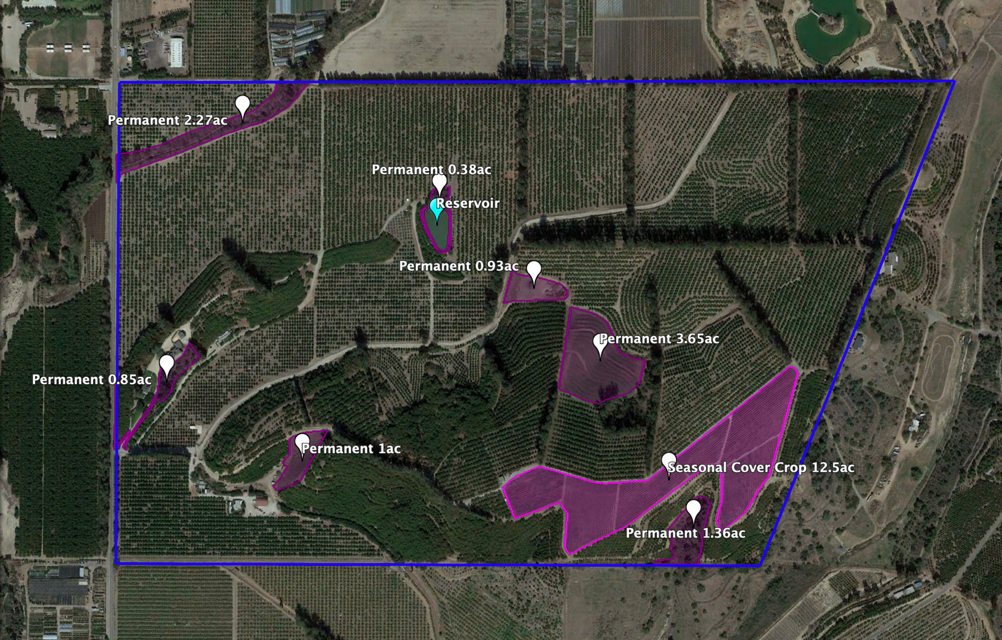

Donlon Habitat Areas
Permanent: 10.44ac
Seasonal: 12.5ac
TOTAL = 22.94 acres

