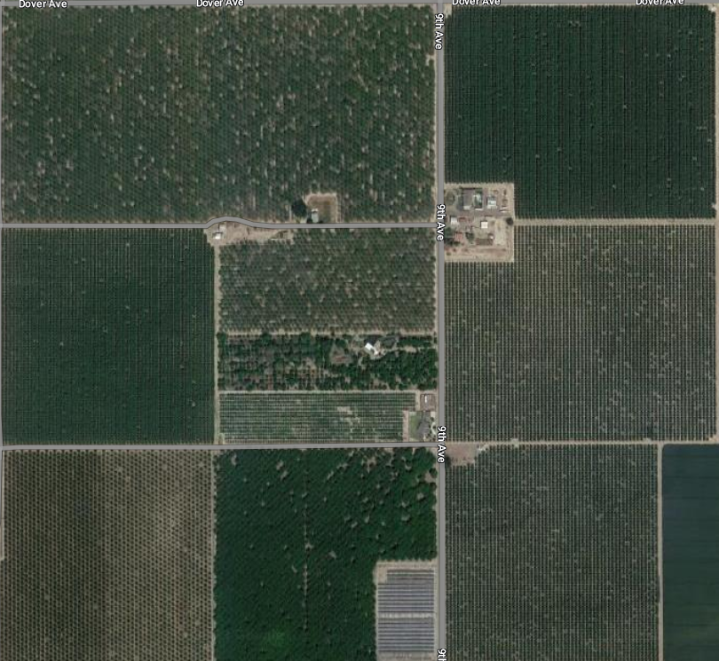

Cover crop in each row, Walnuts

Water resource, Floral resource, and nesting

ALMONDS

