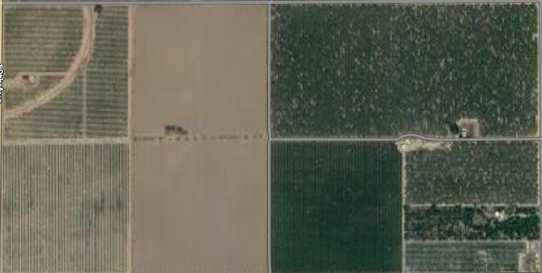

Cover crop in each row, Walnuts

Floral resource and nesting

Water resource

Almonds

