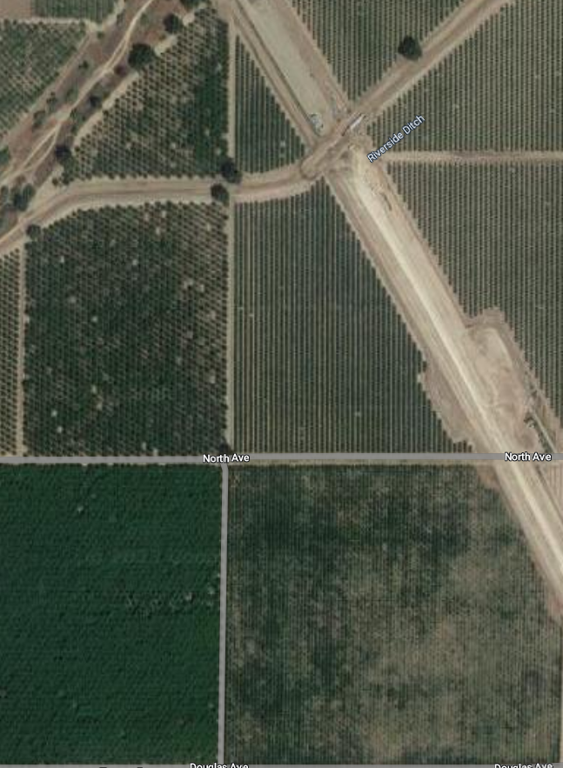

Floral resource and nesting

Water resource

Cherries

Cover crop in each row,

Almonds

