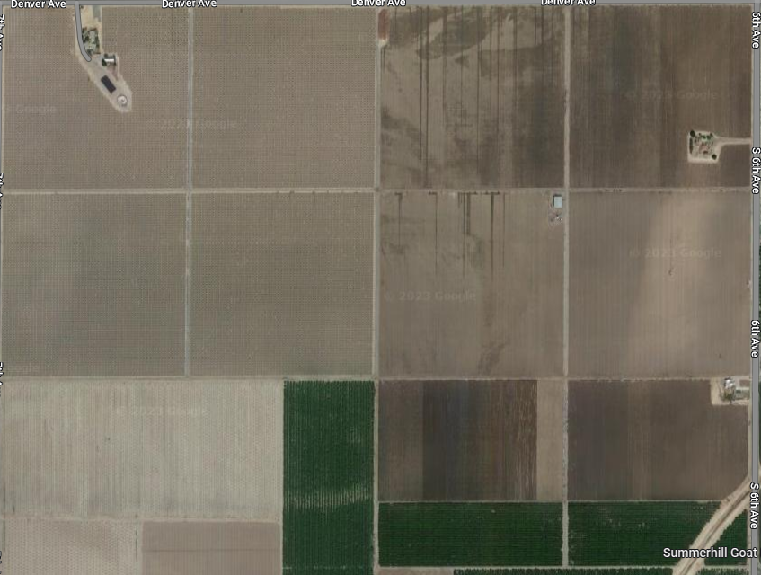

Floral resource and nesting

Water source

Cover crop in each row

Almonds

