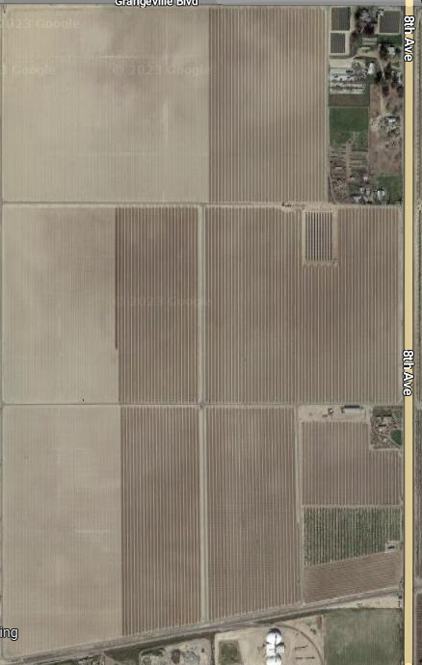

Floral resource and nesting

Water resource

Citrus

Cover crop in each row

Almonds

