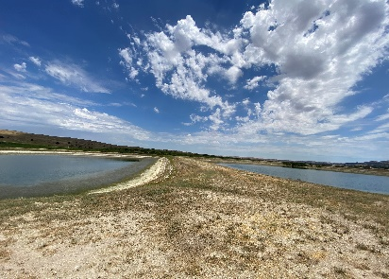

Hedgerow #1

Hedgerow #2

Beehive

Beehive Tree

H4-A-1 Rows 1-8 Cover Crop

Hames Reservoir 1 & 2

**Hames Vineyard**

**72125 Jolon Road Bradley, CA** 9346

Entrance to H4

Hames Reservoir 3 & 4

Main Entrance to Hames Ranch

Hames Reservoir 4 & 5