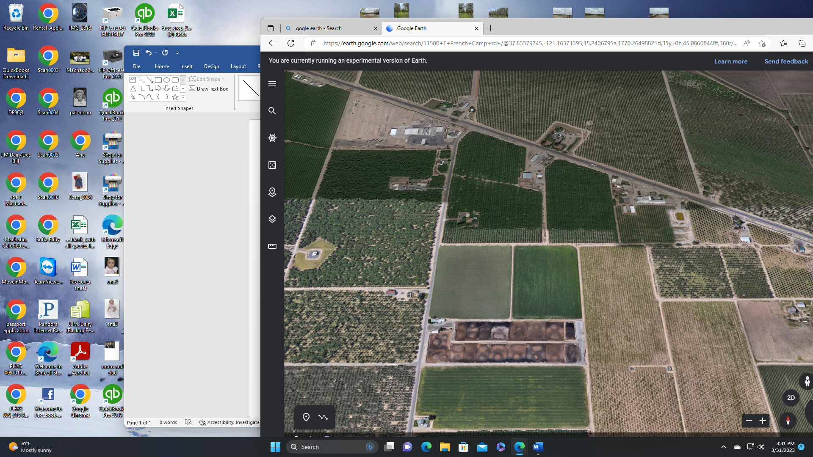

JM & Daughters - 2 orchards

Open Dirt/ water res

Open Fields