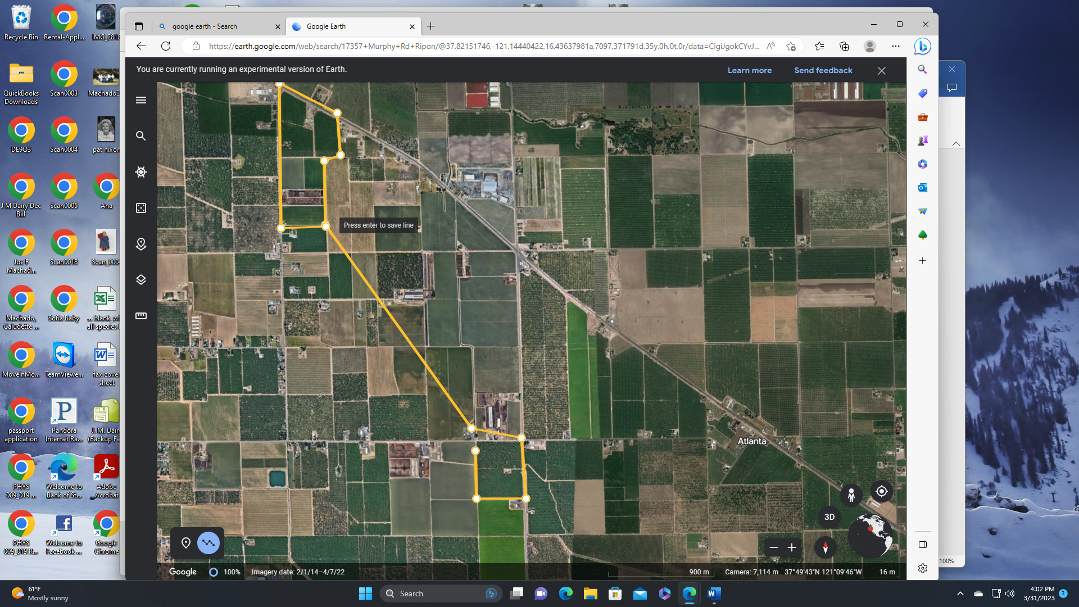

JM & Daughters Orchards

all within 2 miles