**WILD FARM ALLIANCE**

**Pollinator Plan for Scheid Vineyard Hedgerow Planting**

**4/29/24**

**PARTNER PLANING**

Wild Farm Alliance Main Contact: Jo Ann Baumgartner,

[joannb@wildfarmalliance.org](mailto:joannb@wildfarmalliance.org), 831-761-8408, ex 2

**Farm Contacts and Background**

**FARM** Main Contact: Walter Chavez, [walter.chavez@scheidfamilywines.com](mailto:walter.chavez@scheidfamilywines.com),

831-970-8719

**Farm Manager:** Abel Lara, [abel.lara@scheidfamilywines.com](mailto:abel.lara@scheidfamilywines.com)

**Mailing Address**: 72125 Jolon Rd, Bradley, CA

**Project Site GPS: 35°53'38"N 120°54'15"W**

**Name to Put on Check:** Scheid Vineyards California Inc.

**FARM APN: 423-091-025-000, 423-091-038-000**

Total Farm Acres: 3,000 acres in Bradley and Salinas areas

Crops Grown: Wine grapes

**Goals**

Planting these hedgerows and cover crops will meet the owner’s goal to increase pollinators in the vineyard. Because one of their wine labels showcases pollinators, they would like to support them more. They would also like to comply with the Bee Friendly Farming requirements. Besides pollinators, another goal is to support beneficial insects and birds. Since the parcel is part of their “White Flower Vineyard”, they would like several of the plant species to be selected for their white flowers.

**Description of Planting Site**

This vineyard is in the southern Salinas Valley on what were historically grasslands. The northern back fence and southern front fence of this organically managed vineyard block will be the sites of two hedgerows (see attached map). This northern side of the block is adjacent to grassland. The other three sides are next to their own conventionally managed grapes. When visited in the summer, the hedgerow sites had very few weeds.

**Hedgerow Linear Feet in this Plan:**

Northern back fence: 1,440’; Southern front fence: 2,380’; Total: 3,820’

**Hedgerow Plant List**

See spreadsheets of plants that support pollinators. These plants lack host potential for crop pests and diseases and can be found at regional nurseries. They can be planted 3’ from the wire fences and allowed to grow through them, to reduce the space between the hedgerow and the wine grapes.

**Hedgerow Planting Method/ Spacing:**

Purchasing and Picking up Plants

See pp. 3 and 4 of*Installing Habitat to Increase Farm Diversity* document.

Soil Preparation and Planting

See pp. 3, 5 and 6 of[*Installing Habitat to Increase Farm Diversity*](https://www.wildfarmalliance.org/installing_habitat) document.

Additionally, because of the hardpan, the soil will be ripped before making beds for the hedgerows. Cultivating topsoil running a 3-point hitch disc. Raising bed with runner blade 3 ft wide and 1ft tall for hedgerow.

Irrigation

Irrigation will be done with drip, making sure not to include any fertilizer in the water, which would make the plants grow too fast and fall over. Attention to irrigation will ensure survival. Plants must be kept moist in the dry season for three years.

Mulch

A 6” layer around plants will be needed to be placed right after planting to keep weeds down and moisture in soil.

Monitoring and Maintenance

See p. 8 of*Installing Habitat to Increase Farm Diversity* document.

**Cover Crop Planting Method/ Spacing:**

Acreage:

A 4-foot band of cover crop mix will be planted in block H4-A-1 Rows (1-8) for a total of 1.7 acres.

Species List:

***Low Profile Beneficial Habitat Mix OMRI LISTED COATINGS*** *(L. A. Hearne Co.)*

26% Trefoil

10% Red Clover

10% Crimson Clover

5% Creeping Red Fescue

5% Hard Fescue

27% Subterranean Clovers

5% Persian Clover

1% Cal Poppy

2% Baby's Breath

2% Bachelor Buttons

.50% Alyssum

.25% Yarrow

.25% Phacelia

Seeding Rate:

25 lb. per acre

Soil Preparation:

Cultivating topsoil running a 3-point hitch disc.

Planting Method:

Will use a 6ft seed drill for cover crop.

Type of Irrigation, If Needed:

Overhead sprinkler irrigation.

Planting and Termination Dates:

The proposed planting date is late spring.

**Project Score**

COMET PLANNER RESULTS (http://comet-planner-cdfahsp.com/):

3,820’ Hedgerow = 7 metric tons of CO2 Equivalents

1.7 acres of cover crop = 3 metric tons of CO2 Equivalents

**Project Map**

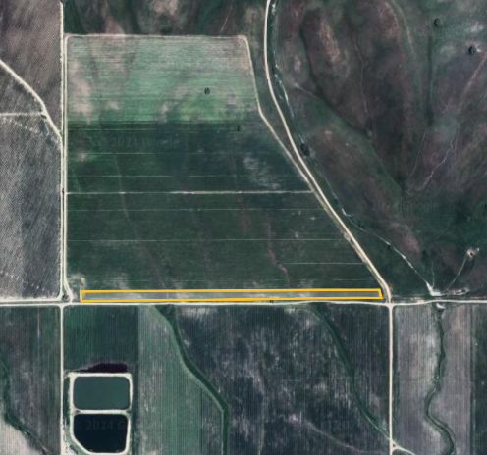

**Photo Documentation**

Take 3-5 geotagged photographs of fields showing established hedgerow plants. Photos are taken at both ends & middle of each hedgerow.

A geotagged photograph is a photograph which is associated with a geographic position by assigning a latitude and longitude to the image. For pictures taken with a mobile phone or digital camera, this can be achieved by enabling the GPS function of the device prior to capturing a picture. Geotagging helps CDFA confirm the correct location of practice implementation consistent with Project Design at the time of verification. Please check the link https://www.cdfa.ca.gov/oefi/healthysoils/docs/InstructionsOnHowToTakeGeotaggedPhotos.pdf for instructions on how to take and send geotagged photos.

**Receipts**

Receipts of plants and seeds purchased are required for reimbursement, including the final numbers of each species purchased.

**Other Requirements**

Recipients are expected to be responsive to requests for information about the project, and to report outcomes for a period of three years after project completion. The purpose of this report is to evaluate the long-term success of PHP awarded projects.