**Field 812, Nebraska and Amber (Selma, CA)**

**9 Rows of Cover Crop**

**140 lbs; 2 acres**

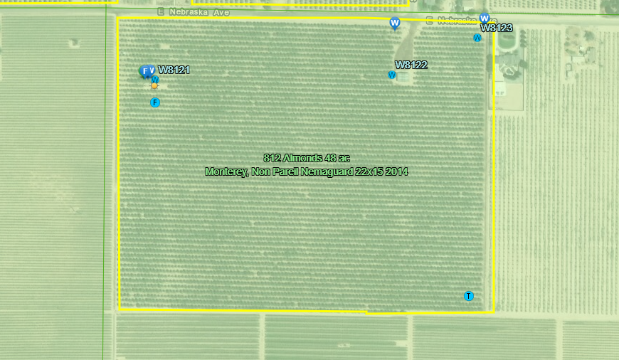

**Field 813, Bethel and Central (Sanger, CA)**

**11 Rows of Cover Crop**

**140 lbs; 2 acres**



