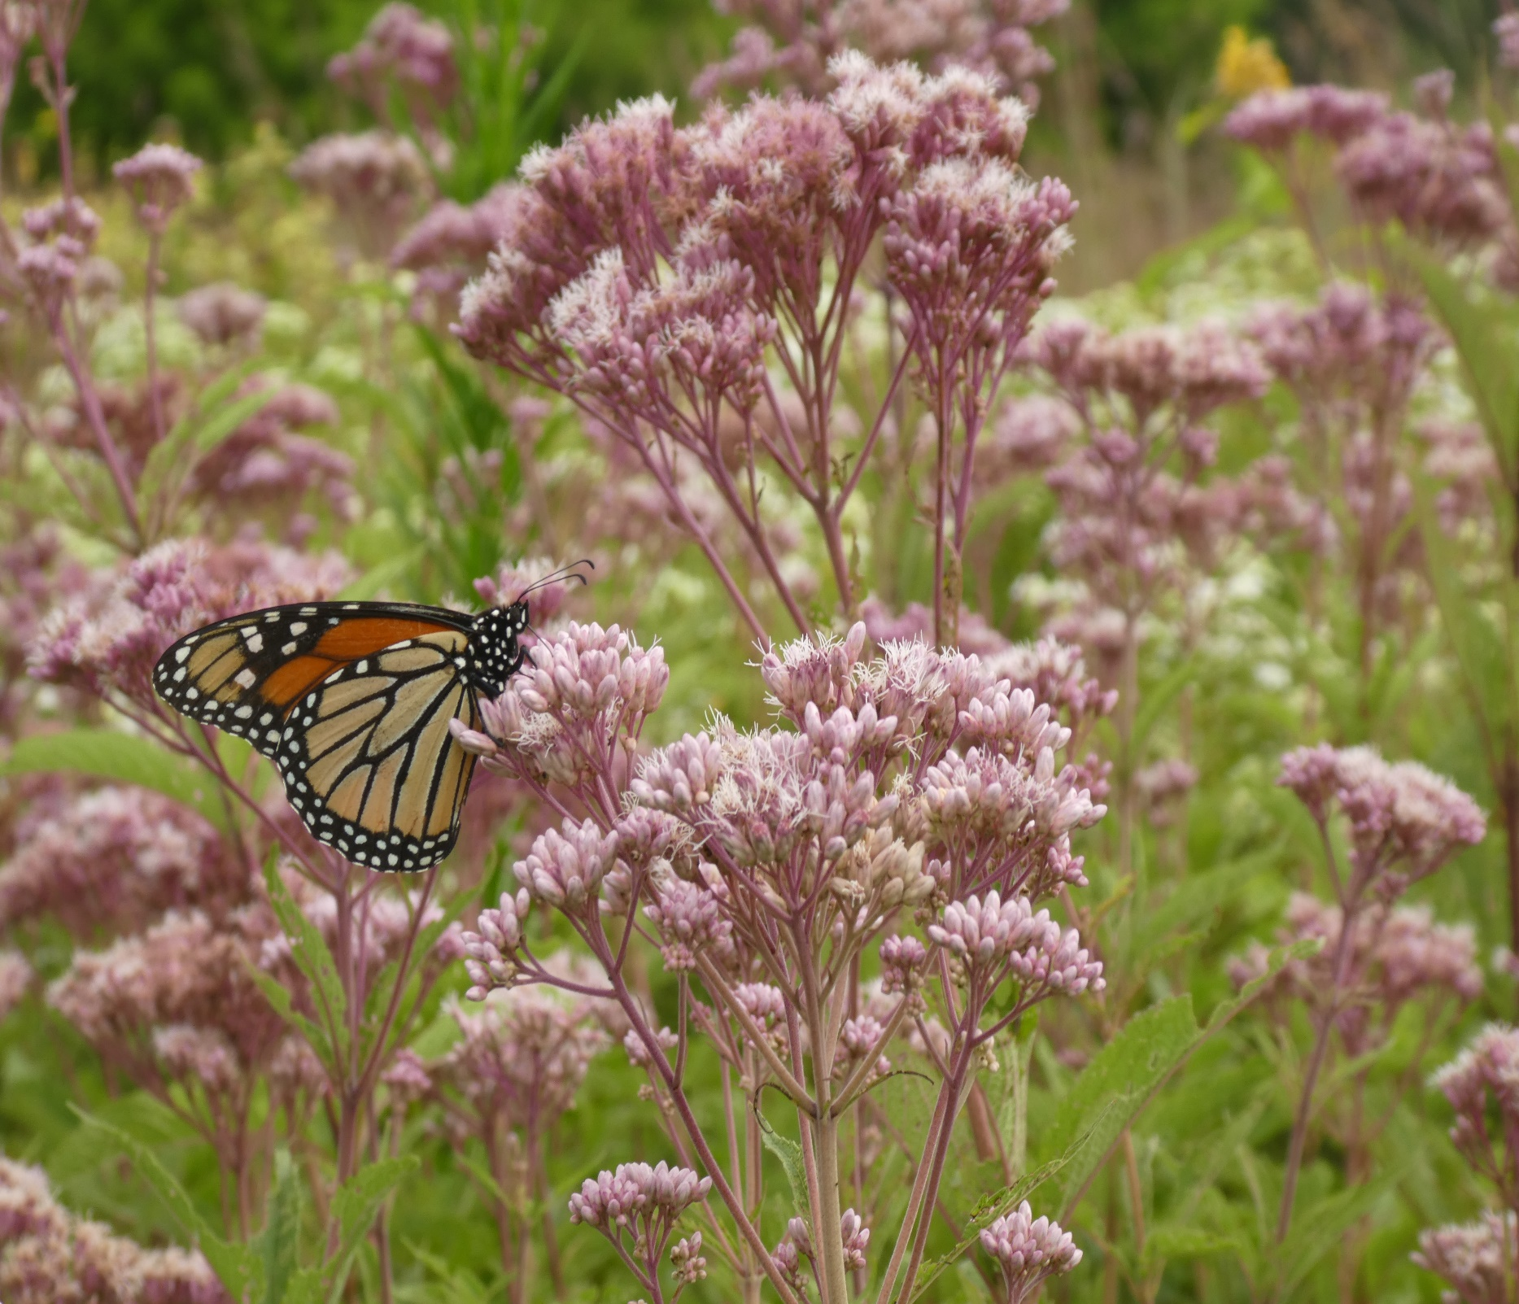

|  |
| --- |
| 2022  Sponsorship  Prospectus |
|  |
| Kelly Rourke  [nappc@pollinator.org](mailto:nappc@pollinator.org)  415-362-1137 |

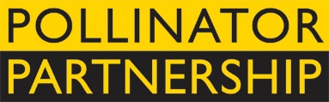

# 2022 Sponsorship Opportunities

|  |
| --- |
| We at Pollinator Partnership are gearing up for **three** exciting pollinator events!  1. 2022 Pollinator Poster: Wings of Life – Pollinating Butterflies and Moths 2. 16th Annual Pollinator Week: June 20-26, 2022 3. 22st Annual NAPPC Conference: Hosted at the Smithsonian NMNH   The popularity of these major initiatives has brought the importance of pollinator health to the forefront of a vast diversity of audiences, including educators, government agencies, for-profit and non-profits, gardeners, beekeepers, industry, and more! Please consider sponsoring these amazing initiatives. Visit [www.pollinator.org/nappc/sponsor](https://www.pollinator.org/nappc/sponsor) to learn more. |
| *Your donation now gets a year’s worth of exposure*  *in 3 ways!* |
| NAPPC ACCOMPLISHMENTS:   * Initiated NAS NRC study, “Status of Pollinators in North America” * Created Pollinator Week, acquiring 50 Governor Proclamations annually * Created 60+ Ecoregional Planting Guides for North America * Provides free information at [www.pollinator.org](http://www.pollinator.org); including books, guides, and webinars * Funded over 50 research grants for Honey Bee Health * Support to create the Congressional Pollinator Protection Caucus (CP2C) * Signed 15 agreements with Federal Agencies influencing 2 billion acres of land * Influence in the creation of the Presidential Memorandum on Pollinators and the National Strategy to Promote Health of Honey Bees and Other Pollinators * And many more! |

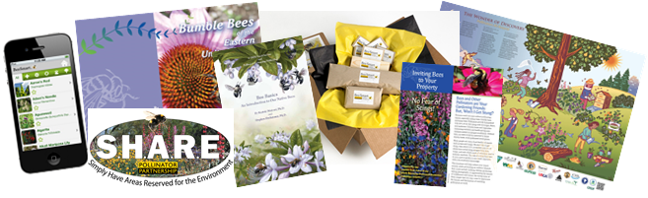

## SPONSORSHIP FORM

YES! I would like to sponsor as a:

|  |  |
| --- | --- |
| ( ) Diamond Sponsor $50,000+ | ( ) I would like copies of the poster sent   to the below address  ( ) I would like to donate my portion of   the posters |
| ( ) Platinum Sponsor $20,000 |
| ( ) Gold Sponsor $15,000 |
| ( ) Silver Sponsor $10,000 |
| ( ) Bronze Sponsor $5,000 |
| ( ) Copper Sponsor $1,000 | |
| ( ) Pollinator Friend $500 or product contribution | |

If you are sponsoring at the Bronze level or above, and would like your logo included on the poster, we will need the following information no later than 3 PM EST, Friday, February 18th:

* This completed form and your organization’s logo should be sent as a .jpeg, .eps, .png, or .ai sent to Reed Lievers at [reed@pollinator.org](mailto:reed@pollinator.org%20)

NAME _________________________TITLE____________________________

ORGANIZATION __________________________________________________

ADDRESS _______________________________________________________

PHONE _______________________ E-MAIL __________________________

Complete and return this form to the attention of:

Reed Lievers

Pollinator Partnership

600 Montgomery St., STE 440, San Francisco, CA 94111

[reed@pollinator.org](mailto:reed@pollinator.org)

T: (415) 362-1137

Checks are payable to Pollinator Partnership, reference 2022 Sponsorship

OR

You may pay online here (<https://www.pollinator.org/nappc/sponsor>)

*Your donation is fully tax deductible and contributes to the protection of pollinators.*

1) 2022 POLLINATOR POSTER

In past years, NAPPC posters have been a great success, and we are excited to share with you the opportunity to have your organization’s logo on the 2022 poster.

Posters are distributed to schools, fairs, conferences, homes, educational trainings, and Pollinator Week events. The posters have no time or date on them, so they are always relevant to the conversation. They are extremely popular for pollinator education and outreach purposes. See past posters at [www.pollinator.org/shop/posters](https://www.pollinator.org/shop/posters).

This year’s poster will be available for distribution by or before Earth Day, Friday, April 22, 2022.

If your organization would like your logo on the poster and copies of the poster, please consider sponsoring at the Bronze level ($5,000) or above by Friday, February 18th!

Wings of Life – Pollinating Butterflies and Moths

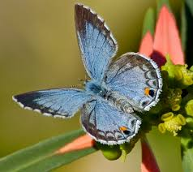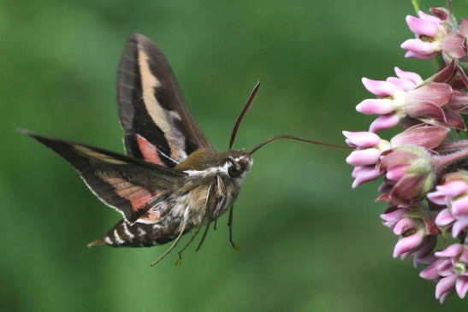This year’s poster will focus on the order of Lepidoptera (butterflies and moths), and the essential role they play in pollination, culture, and ecosystem services throughout North America. Butterflies and moths are found in almost every terrestrial ecosystem from deserts to tropical rainforests, and thousands of flowering plants have evolved to rely specifically on their pollination services, although not all species in Lepidoptera are considered pollinators. Certain plants like Indian paintbrush have evolved to attract butterflies through their brightly colored flowers that open during the day, while others, like Yucca, put out especially fragrant and pale-colored flowers to attract moths that pollinate at night. Most butterflies are diurnal (day-active), and so moths are vitally important for the role they play in pollination at night. They also provide pollination to certain flowering plants like honeysuckle that are not visited by bees and other pollinators during the day.

2) Pollinator Week June 20-26, 2022

Fifteen years ago the U.S. Senate’s unanimous approval and designation of the final full week in June as Pollinator Week marked a necessary step toward addressing the urgent issue of declining pollinator populations. Pollinator Week has now grown to be an international celebration of the valuable ecosystem services provided by pollinating animals. The growing concern for pollinators is a sign of progress, but it is vital that we continue to maximize our collective efforts.

Pollinating animals, including bees, birds, butterflies, bats, beetles and others, are vital to our delicate ecosystem, supporting terrestrial wildlife, providing healthy watersheds, and more. Pollinator Week is a prime opportunity to get the message of the importance of pollinators out to as many people as possible.

Pollinator Week Highlights:

* Officially designated by the U.S. Senate and the U.S. Dept. of Agriculture in 2007
* 50 Governors have declared State Pollinator Week
* Pollinator Week brings together a diverse community of interested parties: government officials, farmers, ranchers, non-profit groups, teachers, school children, clubs, and a whole range of interested citizens taking action for pollinators
* Constantly updated Pollinator Week website with event listings, useful resources, and more!

Get planning for Pollinator Week 2022: [www.pollinator.org/pollinator-week](https://www.pollinator.org/pollinator-week)

3) 21ST Annual NAPPC International Conference

Hosted at the Smithsonian National Museum of Natural History

October 18 - 20, 2022

CONFERENCE

The 22nd Annual NAPPC International Conference is an invitation-only strategic event that brings together the world’s preeminent scientists and pollinator experts to discuss current issues affecting pollinators and ways to further pollinator conservation.

ABOUT

The North American Pollinator Protection Campaign (NAPPC) is a private-public collaborative body that works to promote and protect pollinators. NAPPC is coordinated by Pollinator Partnership, a 501(c)3 non-profit organization.

NAPPC is a growing, collaborative body of more than 160 diverse partners. Respected scientists, researchers, conservationists, government officials and dedicated volunteers are succeeding with major programs to protect pollinators, to raise pollinator-related issues, and to benefit the health of all species – particularly those most threatened.

More information about NAPPC and the 22nd Annual NAPPC international Conference can be found at [www.nappc.org](http://www.nappc.org).

Some Previous Sponsors Include:

Almond Board of California

American Beauties

American Beekeeping Federation

American Honey Producers Association

American Seed Trade Association (ASTA)

Blue Diamond Growers

The Boeing Company

Bureau of Land Management

Burt's Bees

California State Beekeepers Association

CropLife America

Nutrien Ag Solutions

Cypress Creek Renewables

Edison Electric Institute

EPRI

Francis Ford Coppola Winery

Greif/Soterra

Kettle Brand Chips

Levin Family Foundation

Monarch Watch  
National Association of Landscape Professionals

National Association of Wheat Growers

National Corn Growers Association

National Farmers Union

National Park Service

noosa yoghurt

Nufarm

Project Apis m.

Select Seeds

Smithsonian Institute

USDA APHIS

US Apple Association

US EPA

USGS

USDA ARS

USDA NIFA

USDA NRCS

US Fish and Wildlife Service

US Forest Service

US Golf Association

Wakefern Food Corporation

Waste Management

Wyman's of Maine

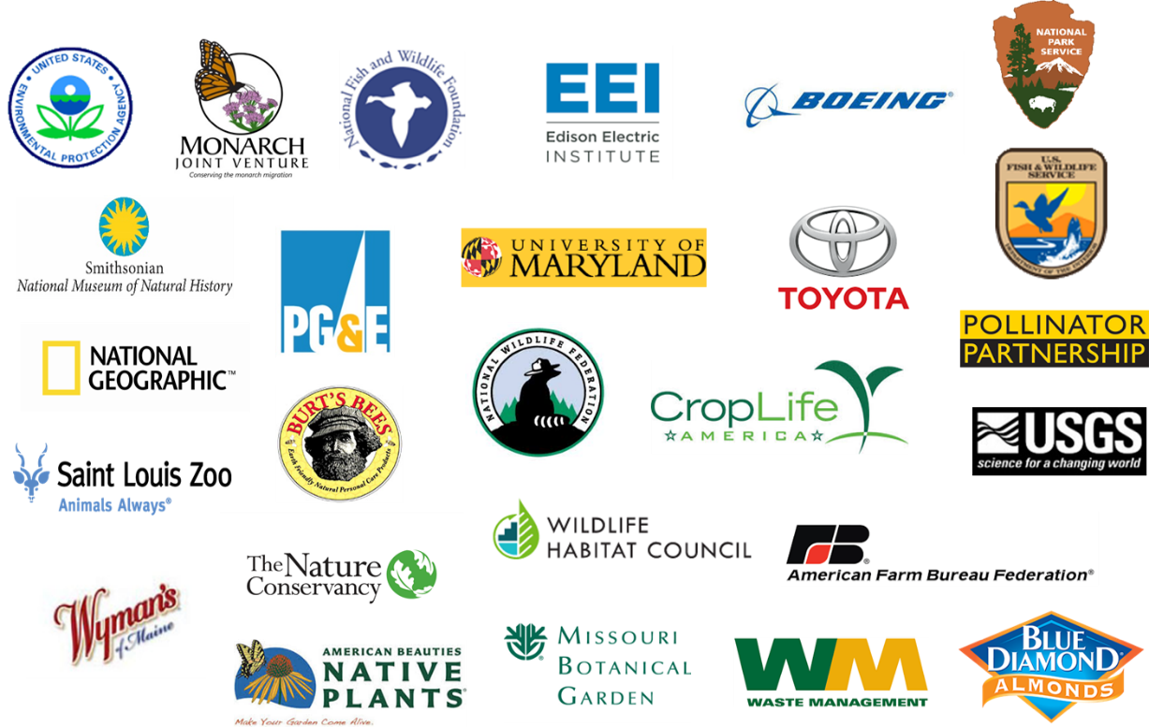

SPONSORSHIP LEVELS

Diamond Sponsor $50,000+

*Same as below plus:*

Conference registration for four representatives

500 copies of the 2022 pollinator poster

Platinum Sponsor $20,000

*Same as below plus:*

Product/literature inclusion in conference materials (upon request)

400 copies of the 2022 pollinator poster

Gold Sponsor $15,000

*Same as below plus:*

Conference registration for two representatives

300 copies of the 2022 pollinator poster

Silver Sponsor $10,000

*Same as below plus:*

200 copies of the 2021 pollinator poster

Bronze Sponsor $5,000

*Same as below plus:*

Conference registration for one representative

Logo representation on the 2022 pollinator poster

100 copies of the 2022 pollinator poster

Copper Sponsor $1,000

*Same as below plus:*

50 copies of the 2022 pollinator poster

Pollinator Friend $500 or product contribution

Acknowledgement of support during NAPPC Conference

Acknowledgement of support during Pollinator Week

Pollinator Partnership’s Giving Policy

*Diversity of funding sources is an essential part of P2’s commitment to the spirit of its diversity of stakeholders and the execution of its programs. P2 is committed to seeking funding from a broad spectrum of organizations and individuals whose support will advance P2’s goals and objectives. P2 will only accept financial support from donors who accept the following criteria. Funders must recognize and respect P2’s mission; funders must understand and accept that they have no right or power to determine the content of P2 programs, opinions, or information materials, nor influence the selection of issues. Funders are aware that contributing to P2 does not bind them to P2 positions nor does it authorize P2 to speak for the contributing organization. Acceptance of a grant does not imply that P2 approves nor endorses the funder’s activities or products.* [*Click Here*](https://www.pollinator.org/pollinator.org/assets/generalFiles/GRANT-AWARD-AND-GIFT-ACCEPTANCE-POLICY-2020.pdf) *to view P2’s Gift Acceptance Policy.*