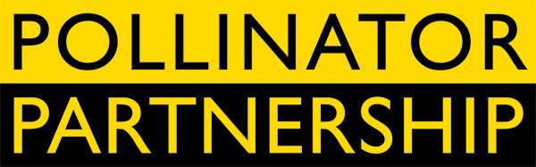

June 20, 2014

For Immediate Release

Tom Van Arsdall TVA@pollinator.org 703.509.4746
Laurie Davies Adams LDA@pollinator.org 415.362.1137

Pollinator Week 2014 Culminates in Presidential Memorandum
Leaders across the Nation Mobilize for Pollinators

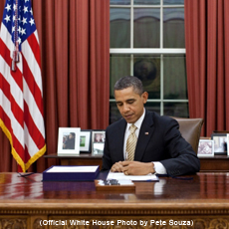
The White House today announced the first comprehensive pollinator initiative ever created across the federal government. This morning President Barack Obama signed a Presidential Memorandum to bring federal actions to the pollinator issue that will provide increased collaboration, solid science, practical management, and essential research goals. The Presidential Memorandum works through coordinated efforts and will increase efficiencies and effectiveness. The Pollinator Partnership acted as a resource to the White House for many months as the White House Executive Office brought stakeholders together and canvassed federal departments and agencies. Among the directives in the memorandum are actions increasing forage on federal lands, assessing the effects of pesticides including neonicotinoids, including native seeds in post-fire restoration, landscaping federal facilities for pollinators, educating the public about pollinators, and more. All details are at http://pollinator.org/PR_whitehouse.htm.

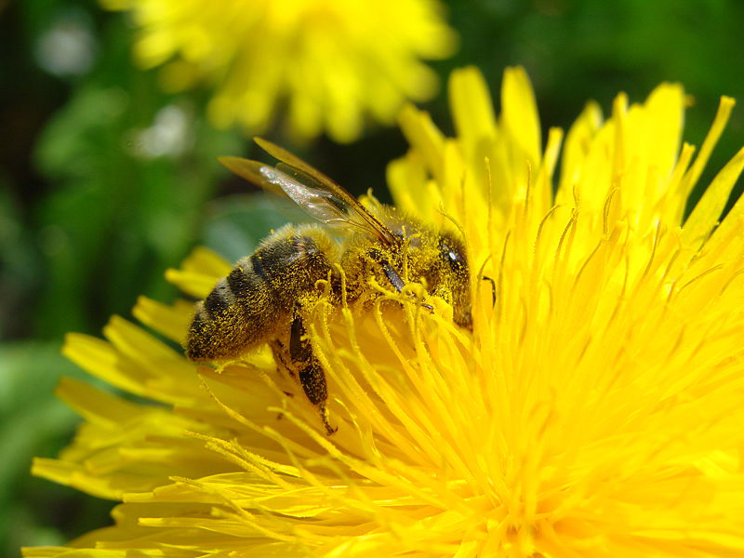
For the Pollinator Partnership, the memorandum is the result of a nearly 20-year campaign to increase awareness and action for honey bees and other pollinators and marks a new dawn of wise land management across the country. The Presidential Memorandum is a first for comprehensive terrestrial conservation and for pollinators – it demonstrates real leadership on the part of the President and his science team. Importantly, President Obama is joined in supporting pollinators by the bi-partisan list of 45 governors who have signed proclamations for National Pollinator Week supported by millions of constituents across the country who care about this issue. Pollinator Partnership’s Executive Director, Laurie Davies Adams, noted “This Presidential action shows visionary leadership and offers practical measures that will help pollinators now; it is a triumph for people, plants and pollinators.”

Details about the Presidential Memorandum are being shared today at a Pollinator Briefing in Washington, DC organized by the Pollinator Partnership in collaboration with the Congressional Pollinator Protection Caucus (CP2C) headed by of Rep. Alcee Hastings (D-FL) and Rep. Jeff Denham (R-CA), co-chairs of CP2C. The briefing features Dr. Anne Kinsinger, US Geological Survey, Earl Stewart, U.S. Forest Service and Laurie Davies Adams, discussing the Presidential Memorandum and public-private efforts to support pollinators. Adams introduced the newly-formed Business for Bees, a collaboration to support pollinators that brings “business know-how” to cooperative conservation and includes Toyota North America, the Boeing Company, General Mills, Greif, Burt’s Bees, among others. See http://pollinator.org/bizforbees.htm for details.
Also discussed at the briefing will be the Highways BEE Act (www.pollinator.org/BEEAct.htm), introduced by Reps. Denham and Hastings will be discussed. The briefing will connect hundreds of Congressional staff members and help them understand and recognize the importance of pollinators to our world. They will hear first-hand about the efforts that the federal government has planned.

There will be an informational break following the Congressional Briefing featuring Burt’s Bees Lip Balm and Häagen Dazs ice cream – perfect pollinated products to cap Pollinator Week in the Capitol, where the nation’s leaders are responding to the needs of pollinators with comprehensive and meaningful actions.

Pollinator Week has grown exponentially in scope each year since its inception in 2007. This year, U.S. Secretary of Agriculture Tom Vilsack, U.S. Secretary of the Interior Sally Jewell, and 45 governors designated June 16-22 through proclamations—the most ever—as a week to celebrate and protect the nation’s pollinating animals. A complete list and scanned versions of the proclamations are available at (http://pollinator.org/npw_events.htm). “It is really satisfying to see how many individuals in every state got involved in this project,” commented Kelly Rourke of the Pollinator Partnership, who coordinated the campaign to engage states.

Pollinators, like bees, butterflies, birds and other animals, bring us one in every three bites of food and maintain our environment. Pollinators are responsible for about $16 billion in U.S. agricultural production and world-wide human food production at $190 billion. Pollinators form the underpinning of a healthy and sustainable future for food and the environment, but have shown disturbing signs of decline. Efforts during Pollinator Week, and indeed year-round, are working to reverse and prevent pollinator declines. Sunny Boyd, of the Pollinator Partnership remarked “Our steady drumbeat through the years has brought understanding and commitment across the country on a local as well as a national level. Pollinator Week helps to increase the discussion of all the issues, from community beekeeping regulations to the elimination of the impacts of pesticides on pollinators.”

###

ABOUT THE POLLINATOR PARTNERSHIP (P2)
Established in 1997, the Pollinator Partnership is the largest 501(c) 3 non-profit organization dedicated exclusively to the health, protection, and conservation of all pollinating animals. Pollinator Partnership’s actions for pollinators include education, conservation, restoration, policy, and research. P2’s financial support comes through grants, gifts, memberships and donations from any interested party. Its policies are science-based, set by its board of directors, and never influenced by any donor. To make a donation, or for information on events during Pollinator Week, visit www.pollinator.org.

