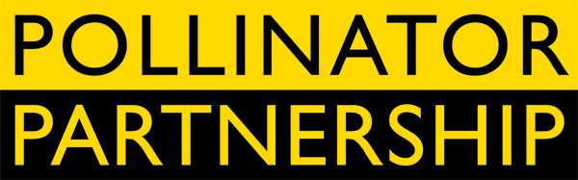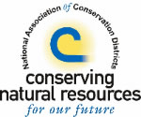

FOR IMMEDIATE RELEASE

Contacts: Victoria Wojcik, Pollinator Partnership, vw@pollinator.org, 415.362.1137
Bethany Shively, NACD, bethany-shively@nacdnet.org, 202.547.6223
California Farmer Receives International Award

Washington, D.C. (October 21) - Paul Kaiser of Singing Frogs Farms in Sebastopol, California is the 2010 recipient of the NACD-NAPPC Farmer Rancher Pollinator Conservation Award, sponsored by North American Pollinator Protection Campaign (NAPPC) and the National Association of Conservation Districts (NACD). The award was given as part of an international effort to promote public awareness about pollinators – birds, bees, bats, butterflies, beetles, and other animals that enable the reproduction of over 75 percent of flowering plants, accounting for as much as one-third of the nation’s food supply.

Laurie Davis Adams, Executive Director at Pollinator Partnership (NAPPC’s managing organization) spoke with approval about Mr. Kaiser and his work: “Paul Kaiser and Singing Frogs Farm are leading by example. They have made a concerted commitment to providing safe pollinator habitat, are turning their consumers and other producers on to pollinators and pollinator conservation.”

Singing Frogs Farm is a certified Bee Friendly Farming™ (BFF) operation, signifying that the operation meets or exceeds minimum criteria for providing adequate habitat for bees and other pollinators and using bee-beneficial practices. Farm tours and open houses hosted by Paul and his family continuously bring visitors onto his land and help to spread the word about the role that pollinators play in agriculture and the actions that are necessary to protect and support them. Thus, Singing Frogs Farm produces more than food – they grow consumer consciousness and environmental stewardship.

“As front-line stewards of our nation’s natural resources, conservation districts value the important role of pollinators in supporting healthy ecosystems and the food-producing plants that feed the world,” said NACD President Steve Robinson. “This is why it’s so important that Mr. Kaiser and other conservation-minded producers around the country are actively investing in stewardship and management practices to protect and preserve declining pollinator habitat.”

Upon hearing that Paul has won this award, members of his CSA took action and raised the funds necessary to cover travel expenses so that he could attend the ceremony at the USDA in Washington, D.C. Holly White-Wolfe, a Singing Frogs Farm CSA members spoke of the impact that this local producer has on the community:

"I look forward to every opportunity I have to bring my family to visit Singing Frogs Farm - “our farm” - where we can experience a deep connection to our food and our farmers. Paul and Elizabeth give us a bountiful weekly box of tasty produce that keeps our family well fed and well nourished, but they give us so much more. They give us proof that farming can be done in harmony with nature.”

The award ceremony initiated the 10th Annual International NAPPC Conference, an annual meeting that brings together some of the country’s most prominent scientists and pollinator experts. NAPPC consists of 120-plus organizations in the U.S., Canada and Mexico that work to promote public awareness of the importance of pollinators. NAPPC is managed by the non profit Pollinator Partnership. The NAPPC Conference is being hosted this year by the U.S. Department of Agriculture. To learn more about the Pollinator Partnership and the North American Pollinator Protection Campaign visit www.pollinator.org.

The National Association of Conservation Districts (NACD) represents America’s 3,000 conservation districts, which are local units of government established under state law to carry out natural resource management programs at the local level. Districts work with millions of cooperating landowners and operators to help them manage and protect land and water resources on all private lands and many public lands in the United States. To learn move about NACD, visit: www.nacdnet.org.

###

