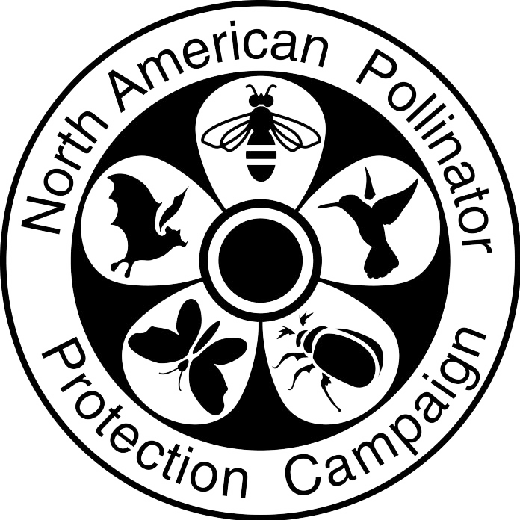

## **NAPPC Roadside Management Award**

Use as much space as needed to completely answer each question. Self-nominations are accepted.

**Contact Information (Nomination Submitter)**

Name:_______________________________ Organization:________________________

Email: _______________________________ Phone Number: ____________________

**Government Agency Information (Nominee)**

Government Agency Name: _____________________________

Employee Contact Name: ____________________________

Title: _______________________________ Email: ________________________________

Phone Number: ________________________

**Please address each of the questions below in as much detail as possible.**

How has the agency demonstrated a long-term commitment to pollinators?

How is the agency implementing vegetation management practices (e.g., conservation mowing, targeted herbicide use, training etc.) that incorporate the needs of pollinators? Provide three examples.

How has pollinator supporting vegetation been incorporated into the agency’s operations? Describe how species are selected if pollinator-friendly plantings are used (e.g. native vs. non-native, number of species, expertise used for seed mix design, etc.).

How are locations for pollinator-supporting vegetation selected?

How many documented roadside miles/kilometers are impacted by the agency's pollinator initiative?

Describe how the agency engages the public through education and outreach as well as signage. Include any Pollinator Week activities.

Are the benefits of the agency’s initiative to pollinators monitored, quantified, and/or documented? Is the data from the on-site monitoring reported to the public? Please describe.

Describe any other positive impacts of the agency's pollinator initiative for wildlife and people.

Upload labeled picture(s) of select roadsides the agency has managed for pollinators along with other relevant pollinator activities.